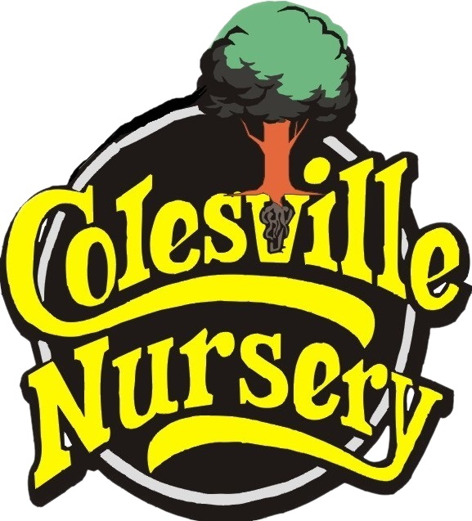

NATIVE PLANT PACKAGE
Classic invasive/non-native plants with their
native alternatives!
All plants listed are typically available on our inventory.
Please always refer to our live website inventory for current availability.

TREES

Sun
Invasive/Non-native Native alternative

FLOWERING CHERRY (Prunus serrulata, subhirtt.) | Chionanthus vir., Malus cor., Magnolia "Little Gem", Magnolia vir.

KOUSA (CHINESE/KOREAN) DOGWOOD | Magnolia virginiana, Cornus florida, Malus coron., Chionanthus vir., Acer sacch.

CLEVELAND PEAR (PYRUS CALLERYANA) | Malus corn., Magnolia virginiana, Cornus florida, Chionanthus vir., Acer rubrum, Acer sacch.

CRYPTOMERIA JAP. "Yoshino & Radicans" | Thuja occ., Juniperus virginiana, Ilex opaca

SHRUBS

Sun
Invasive/Non-native Native alternative

BOXWOODS (Buxus) | Ilex glabra, myrica (wax myrtle), Juniperus virginiana, Ilex opaca

COMPACTA, SOFT TOUCH, HOOGENDORN etc. (Ilex crenata) | Myrica cerifera "Little Bull", Illicium, Ilex glabra, Ilex opaca, Juniperus virginiana "Gray Owl", Chrysogonum vir., Phlox div.

LAURELS: OTTO / SKIPS / ENGLISH | Illicium, Kalmia lat., Rhododendron (native), Myrica cerifera, Ilex opaca, Viburnum nudum/dentatum

EUONYMUS | Myrica cerifera, Illicium, Ilex glabra, Ilex opaca, Juniperus virginiana

ROSES, WEIGELA | Rosa rugosa, Echinacea purpurea, Solidago, Hibiscus moscheutos, Viburnum nudum/dentatum

NON-NATIVE GRASSES: Pennisetum orientale/alop. or Miscanthus sinensis | Panicum virgatum, Pennisetum virgatum, Schizachyrium, Eragrostis spec., Sporobolus, Sorghastrum, Chasmanthium latifolium, Andropogon  Carex penns.

Shade
Invasive/Non-native Native alternative

AZALEA - encore, kurume, murcrunatum, southern indica | Illicium, Kalmia lat., Azalea viscosum, Azalea atlanticum, Azalea canescens, Azalea arborescens,

GARDENIA | Calycanthus, Clethra, Illicium

HYDRANGEA PANICULATA, MACROPHYLLA | Hydrangea arb, Hydrangea quercifolia, Viburnum dentatum, Viburnum trilobum, Viburnum nudum

PERENNIALS
Sun
Invasive/Non-native Native alternative

LIRIOPE | Carex pensylvanica, Erigeron, Phlox div., Phlox sub,

DAYLILY (HEMEROCALLIS) | Echinacea, Lobelia, Pycnanthemum, Gaillardia, Sedum tern.,Erigeron, Solidago, Liatris, Veronicastrum vir.

Shade
Invasive/Non-native Native alternative

ASTILBE | Aruncus dioicus, Chelone, Actaea racemosa

HOSTA / NON-NATIVE HEUCHERA | Tiarella cord., Heuchera "Autumn Bride", Heuchera "Caramel"

IRIS (germanica, siberica, ensata) | Liatris, Solidago, Rudbeckia, Stokesia, Lobelia, Echinacea, Chelone, Allium cernuum, Iris cristata, Veronicastrum

FERNS (Japanese, Autumn, other non-native) | Ferns: Cinnamon, Tassel, Christmas, Lady, Lady in Red, Maidenhair, Dixie Wood, Ostrich

Groundcovers
Sun
Invasive/Non-Native Native
Mondo Grass (ophiopogon), Liriope | Lonicera "Major Wheeler", Phlox subulata,

Shade
Invasive/Non-Native Native
Vinca, Ivy | Virginia Creeper, Chrysogonum vir., Phlox div. , Heuchera "Autumn Bride" or "Caramel", Tiarella cordifolia

